Chapter 17, Solution 34.

Using Fig. 17.70, design a problem to help other students to better understand circuit responses to a Fourier series.

Although there are many ways to solve this problem, this is an example based on the same kind of problem asked in the third edition.

Problem

Obtain v_{o}(t) in the network of Fig. 17.70 if

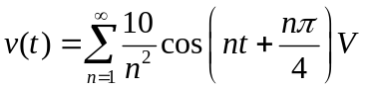

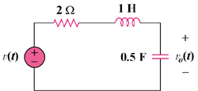

Figure 17.70

Solution

For any n, V = [10/n²]∠(nπ/4), ω = n.

1 H becomes jω_{n}L = jn and 0.5 F becomes 1/(jω_{n}C) = −j2/n
+
V_{o}
−
V

+
−
2 Ω
jn
−j2/n

V_{o} = {−j(2/n)/[2 + jn − j(2/n)]}V = {−j2/[2n + j(n² − 2)]}[(10/n²)∠(nπ/4)]

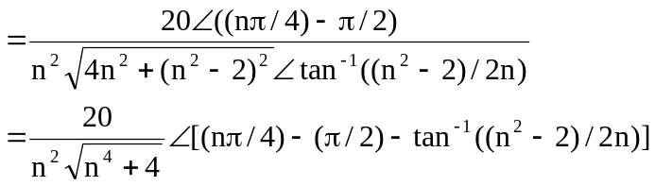

v_{o}(t) = 